**Integration of Angular with Spring Boot**

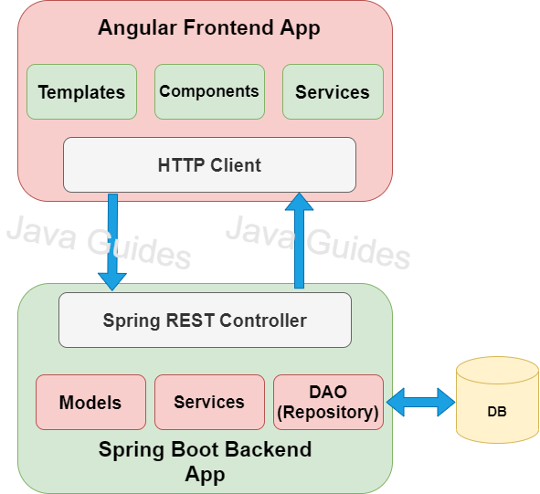

Cross-Origin Resource Sharing (CORS) is a security concept that allows restricting the resources implemented in web browsers. It prevents the consuming the requests against different origin.

For example, your web application is running on 8080 port and by using you are trying to consuming RESTful web services from 9090 port. Under such situations, you will face the Cross-Origin Resource Sharing security issue on your web browsers.

There is two ways to integrated the angular application with spring boot

* Proxy Configuration.
* Using @CrossOrigin annotation

**Proxy Configuration**

Step: 1 – To enable CORS via proxy configuration, we need to generate a src/proxy. conf. json file inside the Angular root folder and also place the following code inside of it.

proxy.conf.json

{

    "/api/*" :{

        "target" : "http://localhost:8080",

        "secure" : false,

        "changeOrgin" : false

    }

}

Step: 2 – Update start script in package.json file.

package.json

"scripts": {

    "ng": "ng",

    "start": "ng serve --proxy-config proxy.conf.json",

    "build": "ng build",

    "watch": "ng build --watch --configuration development",

    "test": "ng test"

  },

Step: 3 – Import HttpClientModule in app.module.ts file.

Step: 4 – Create a new service to consume all APIs.

* Inject HttpClient
* Create methods to consume the APIs using HttpClient and http methods(get, post, put, delete)

users.service.ts

import { HttpClient } from '@angular/common/http';

import { Injectable } from '@angular/core';

@Injectable({

  providedIn: 'root'

})

export class UsersService {

  constructor(private http : HttpClient) { }

  getUsers() {

    return this.http.get<[]>("/api/getAllUsers");

  }

}

Step: 5 – Inject the service in component to use http methods.

app.component.ts

import { Component } from '@angular/core';

import { UsersService } from './users.service';

@Component({

  selector: 'app-root',

  templateUrl: './app.component.html',

  styleUrls: ['./app.component.css']

})

export class AppComponent {

  title = 'demo';

  constructor(private usersService : UsersService) {

  }

  users : any[] = [];

  getAllUsers() {

    this.usersService.getUsers().subscribe( data => {

      this.users = data;

   });

  }

}

app.component.html

<div>

    <table border="1px">

      <tr>

        <th> Name </th>

        <th> Age </th>

        <th> Gender </th>

        <th> City </th>

        <th> State </th>

      </tr>

      <tr *ngFor="let user of users">

        <td> {{ user.name}} </td>

        <td> {{ user.age }} </td>

        <td> {{ user.gender }} </td>

        <td> {{ user.city }} </td>

        <td> {{ user.state }} </td>

      </tr>

    </table><br>

    <button (click)="getAllUsers()"> Get Users </button>

</div>

**Cross Origin annotation**

@CrossOrigin("http://localhost:4200")

@CrossOrigin(“front-end-url”)

@RestController

@RequestMapping("/your_mapping")

public class Your_controlle {

// your logic goes here .//

}